**x**

**Data Structures Programming Project 1**

Nelson Rushton, Texas Tech Computer Science

Fall 2018

By a ***string***we will mean a C++ string, as defined in the C++ string library. Your program should begin with

#include <string>

and then optionally,

using namespace std;

**1. Data Model**

* A ***color***is the character 'B' or the character 'W'. Intuitively, the colors stand for black and white.
* A ***piece type***is one of the following characters: 'p', 'r', 'k', 'b', 'Q', 'K'. Intuitively, piece types stand for pawn, rook, knight, bishop, queen, and king.
* A ***rank*** is one of the following characters: '1', '2', '3', '4', '5', '6', '7', '8'.
* A***file***is one of the following characters: 'a', 'b', 'c', 'd', 'e', 'f', 'g', 'h'
* A rank and a file together describe a cell on the chess board, as shown below. For example, the upper left hand corner of the board is at rank 8, file *a*.

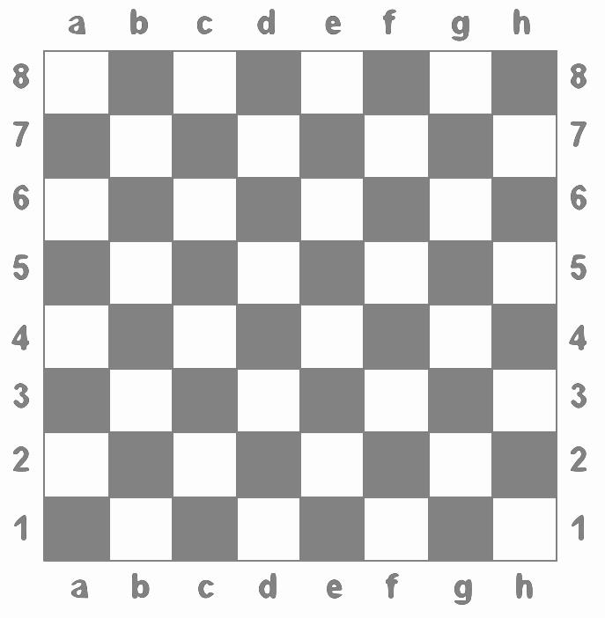

* A ***piece-string***is a string of the form "*ctij*" where *c* is a color, *t* is a piece type, *i* is a rank, and *j* is a file.. The piece "*ctij*"represents a piece of color *c* and type *t* in the square with rank *i* and file j. For example, the piece-string "WQ5g" represents a white queen in the square at rank 5, file *g.*
* A ***puzzle string*** is a string formed by concatenating any number of piece-strings and/or spaces (ascii 32). As a regular expression, puzzle ::= (space | piece-string)*. For example, the following are puzzle strings :

"WQ4aWp4b "

" "

""

" Bp4hWK7c Wp8d "

"Wp3aWQ3b Bp2c"

* A ***piece*** is a two-character C++ string, whose first character is a color and whose second character is a piece type. For example, the following strings are pieces: "WK", "Bp",Wr", "Bk".
* A ***row*** is a C++ vector of eight strings, each of which is either a piece, or the string "e" (designating an empty square). For example, using list notation, the vector ["e", "e", "BQ", "e", "e", "Wk", "e", "e"] is a row.
* A ***position***is a vector or 8 rows. A position represents all the pieces on a chessboard at a particular state of the game, such as the one shown below. If *p* is a position, then *p*[*i*][*j*] is the piece in the (i+1)'st rank, *j* spaces from the left edge of the board, or else "e" if there is no piece there. If *p* is the position illustrated below, then, for example, *p*[7][0] = "BK", *p*[7][1]="Bb", *p*[7][2]="WK", *p*[7][4]="e", *p*[0][0] = "Wr", *p*[0][1]="e", etc.

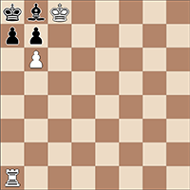

**2. Specification**

Your assignment is to implement a function

position readPosition(string s)

so that if s is a puzzle string representing a chess position, readPosition(s) is the position represented by s. For example, if s = " BK8a Bb8b WK8cBp7a Bp7b Wp6b Wr1a", then readPosition(s) would be the position corresponding to the picture above. You can assume the input string s is a syntactically correct puzzle string and does not contain two pieces in the same square.

For a grade of 100, this project will be due on Tuesday, Dec 4. You will receive more detailed instructions on how to submit from the lab instructor. Students must design their own programs and write their own code. Sharing code with another student, or copying code from another student on this assignment will be considered academic dishonesty.

**Grading:**

Programs that work correctly and are submitted on time (and, of course, are your own work) will receive a grade of 100. I will not grade your style, documentation, etc. There is a 10 point penalty for each week or part of a week after that.

**Notes:**

1. Your program does not need to perform any I/O. It will be tested by linking it with a test program that calls your *position* function.
2. Please do not try to put all your code in one function. You will have several helpers.
3. You will need to define the positiontype using a typedef statement. Define it exactly as specified, to be a vector of vectors of strings.